Project CS-25-317 *Web Notification System with Alexa Integration* *for Improved Independence for TBI/PTSD Patients*

Project Proposal

Prepared for

Kristie Yelinek

Quality of Life Plus

By

Rebecca Browder

Lavale Butterfield

Parker Dizon

Aryan Garg

Under the supervision of

[Tamer Nadeem](mailto:tnadeem@vcu.edu)

Date

11 October 2024

**Executive Summary**

Soldiers, first responders, and many others on the front line during emergencies and disasters may become diagnosed with TBI/PTSD if their jobs put them in traumatic situations. These experiences haunt them for years or even the rest of their lives. People who have TBI/PTSD may need help throughout their day-to-day lives, or need help occasionally so that they can live in the way they hope to.

For this project, we are creating a reminder application with Zoom integration that allows users to have more control over their lives and more freedom to live their lives without the need to rely on others as heavily. In order to accomplish this, we are working with someone who has PTSD and can tell us what works for them versus what doesn’t work so that it is more customized to their situation. This is not the first version of this app as in previous years other students made headway in integrating a reminder app with Alexa and RokuTV for general use. However, this year, we are creating the app with specific client needs in mind. It will be a whole new app that builds from the aspects of previous years that apply to what the client requests. The app will incorporate text-to-speech technology to go along with reminders so that users will know what upcoming events they have throughout the day rather than just hearing an alarm that can easily be ignored.

In order to accomplish the goals of the app, our team has weekly meetings to ensure our team is completing milestones in time as well as separate weekly meetings with our faculty advisor to ensure we are on the right track and that what we are trying to accomplish is feasible. In addition, we meet with our sponsor and client bi-weekly. This way, our design goes along with what the client needs, and the app works in a way that aligns with the client's technological literacy.

**Table of Contents**

Section A. Problem Statement 5

Section B. Engineering Design Requirements 7

B.1 Project Goals (i.e. Client Needs) 7

B.2 Design Objectives 7

B.3 Design Specifications and Constraints 8

Section C. Scope of Work 11

C.1 Deliverables 11

C.2 Milestones 12

C.3 Resources 12

Section D. Concept Generation 13

Section E. Concept Evaluation and Selection 14

Section F. Design Methodology 16

F.1 Computational Methods (e.g. FEA or CFD Modeling, example sub-section) 16

F.2 Experimental Methods (example subsection) 16

F.5 Validation Procedure 16

Section G. Results and Design Details 18

G.1 Modeling Results (example subsection) 18

G.2 Experimental Results (example subsection) 18

G.3 Prototyping and Testing Results (example subsection) 18

G.4. Final Design Details/Specifications (example subsection) 18

Section H. Societal Impacts of Design 20

H.1 Public Health, Safety, and Welfare 20

H.2 Societal Impacts 20

H.3 Political/Regulatory Impacts 20

H.4. Economic Impacts 20

H.5 Environmental Impacts 21

H.6 Global Impacts 21

H.7. Ethical Considerations 21

Section I. Cost Analysis 22

Section J. Conclusions and Recommendations 23

Appendix 1: Project Timeline 24

Appendix 2: Team Contract (i.e. Team Organization) 25

References 27

### Section A. Problem Statement

Traumatic Brain Injury (TBI), Post Traumatic Stress Disorder (PTSD) or other related conditions can often make it difficult to manage daily tasks. Time management and concentration can pose greater challenges for those living with these medical conditions. Keeping track of appointment times or managing medications may require additional assistance.

PTSD can occur after experiencing a traumatic event. Veterans and first responders have a higher risk for developing TBI or PTSD, due to the nature of their work. It is difficult to find the exact number of people who have been diagnosed with PTSD. The U.S Department of Veteran affairs estimates 5 out of 100 adults will have PTSD for a given year. Roughly 13 million Americans had PTSD in 2020 [2]. Between 2000 and 2017, the Department of Defense documented over 375,000 cases of TBI diagnosed among U.S. military personnel worldwide [3]. These conditions can make it difficult to adjust to civilian life or navigate daily routines.

Our client for this project is Karina Medina. She has been diagnosed with PTSD and will collaborate with us to develop an application tailored to her specific needs, while also ensuring it will be useful for others as well. Karina has told us that she would like to be more self-reliant to gain a greater sense of independence in her life.

This project centers on software development, accessibility, and inclusive design, requiring a solid understanding of design principles and web development technologies. Karina has mentioned that she isn't well-versed in complex technology, so we’re also prioritizing the creation of a user-friendly application that can accommodate a wide range of users. The sponsor of this project is the Quality of Life Plus Program (QL Plus), a non-profit organization founded in 2009 to develop tailored solutions for veterans and first responders. QL Plus partners with universities, providing engineering students the opportunity to collaborate with veterans and design solutions that have real-world impact.

Several technological initiatives have been developed to assist individuals with these conditions. Digital assistants like Alexa and Siri enhance accessibility, providing powerful yet general support. Wearable devices, such as the Apple Watch, offer features like reminders and notifications, but some smartwatches can be overly complex to set up for specific needs. Additionally, mobile apps like PTSD Coach, launched in 2011, focus on psychological support through features such as coping skills, symptom monitoring, and access to social or professional resources [4]. However, this app lacks personalized reminders, which may be a key feature that users desire.

Previous iterations of this project aimed to create an application with similar objectives, primarily focusing on facilitating communication between users and caregivers. This included features such as reminders for appointments and medications, as well as integrating with RokuTV or Alexa to enhance user's access to the application. This year, we have shifted our focus from the user-caregiver dynamic to promote greater independence. Karina has expressed that regaining this independence can profoundly impact the lives of individuals in situations similar to hers. The current application builds upon the integration with Alexa, emphasizing the reminder feature derived from the user’s calendar.

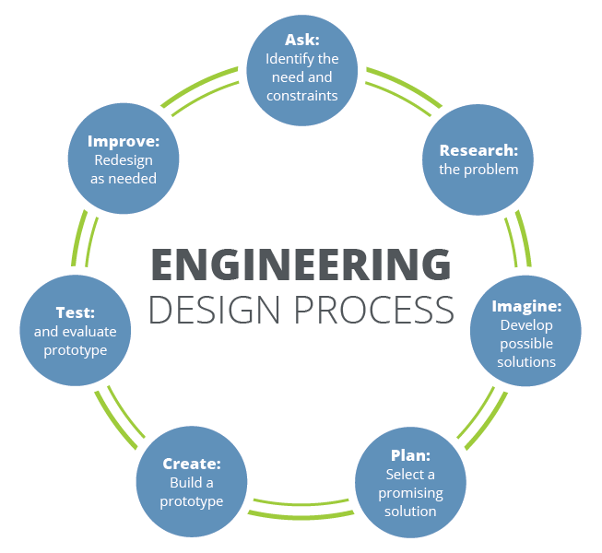

**Figure 1. The iterative nature of the engineering design process [1].**

### Section B. Engineering Design Requirements

This section describes the goals and objectives to make an effective reminder application that meets the needs of our client. This includes the specifications and constraints of the design that has more explanation on how the objectives will be met. Specifically, this section outlines client needs that are the basis for the entire design, objectives that describe how the application should work in order to fulfill the client needs, and ensures that we, as the designers, adhere to what we have promised the client.

#### B.1 Project Goals (i.e. Client Needs)

Sponsored by QLPlus, we’re creating a web application for our client who was diagnosed with PTSD and does not have good time perception when it comes to keeping track of tasks. Within our bi-weekly meetings with our client and sponsor, we have come up with the main goals to be achieved as the end result of the web application.

* To design a notification system that uses text-to-speech integration
* To host all calendar events, meetings, and tasks to do in one place
* To have an application that works in the home and at work
* To integrate with Alexa to announce notifications or reminders and allow the user to create reminders through Alexa
* To have reminders occur in constant intervals from a certain time before the event up until the start of the event
* To keep the application concise without unnecessary options for the client’s needs

#### B.2 Design Objectives

* The design will be simple and easy to use for those who are not familiar with technology.
* The design will allow for Alexa to announce main notifications or reminders for the user.
* The design will allow for the user to customize reminders to ensure that the reminders align with the importance of the task.
* The design will have default settings for users in the case that they do not wish to have to alter any details of the reminder.
* The design will have device priority to ensure that the reminder is seen by the user on one of their devices, but not so that the reminder is on every device at the same time.
* The design will have an icon to guide the user to the web application to ensure ease of access for the user.
* The design will allow for the user to save their information on the website via account creation.
* The design will allow for events and tasks to be added by the user directly on the website as well as by importing them from other apps.

#### B.3 Design Specifications and Constraints

* Design must be completed by the beginning of April 2025
* Development cost of the design must not exceed the $1,000 allocated for the project by VCU
* Design must adhere to standard security protocols for data protection to ensure a safe to use web application
* Design must include a way to introduce the aspects of the web application to the user to ensure an ease of use for the user
* Design must have a customization tool for users to allow for changing of information regarding the reminders they set.
* Design must extract information from Google Calendar and Outlook using their APIs so that events can be imported to the web application
* Design must be able to be used on a variety of devices with an icon for easy access to the web application
* Design must have text-to-speech functionality to ensure users know what the reminder they’re getting is for.

### Section C. Scope of Work

The project scope defines the boundaries of the project encompassing the key objectives, timeline, milestones and deliverables. It clearly defines the responsibility of the team and the process by which the proposed work will be verified and approved. A clear scope helps to facilitate understanding of the project, reduce ambiguities and risk, and manage expectations.

#### C.1 Deliverables

List of Deliverables:

* Team Contract | September 6th, 2024
* Code and Document Repository (Github) | September 13th, 2024
* Project Proposal | October 11th, 2024
* Fall Design Poster/Presentation | November 15th, 2024
* Preliminary Design Report | December 9th, 2024
* Final Design Report | Spring 2025
* Capstone EXPO Poster | Spring 2025

Addressable Issues:

* Access to campus resources might have limited access to necessary facilities for deliverables.
* Variability in team members' schedules and commuting challenges
* Potential technology issues (e.g., software access, internet connectivity).
* Importance of shared drives/folders for efficient document management.
* Possible delays in receiving feedback from stakeholders.

#### C.2 Milestones

The following milestones represent the key phases of our project, essential for delivering successful outcomes from the initial brainstorming session to the Capstone Expo Poster presentation.

During the first two weeks, our team focused on organizing ourselves, assigning roles, and scheduling our regular meetings. We took the time to learn about each other’s strengths and interests, ultimately selecting Aryan Garg as our Project Manager. We also defined specific roles for each team member and established weekly meeting times with our advisor and sponsor. This groundwork was crucial for completing the Team Contract deliverable by September 6, 2024.

As we prepared for our Project Proposal (Introduction) deliverable due on October 11, 2024, we encountered several important milestones. In the two to three weeks following our initial meeting with our advisor, we had the opportunity to connect with our sponsor, QLPlus, and our client, Karina Medina, for the first time. During this meeting, we received a comprehensive overview of the project, which emphasized the necessity of tailoring our application to meet Karina’s specific preferences.

To effectively brainstorm ideas, we sought her input on her goals and expectations for the project, allowing us to gain valuable insights into her vision. Following this discussion, our team engaged in collaborative sessions to generate potential ideas. In preparation for the Project Proposal, we worked on refining our final concepts to present to Karina, carefully analyzing the features we could prioritize, those we would aim to include, and others that might need to be set aside due to the project’s scope.

After our Project Proposal on October 11, 2024, we will take the following two weeks to create a mockup design of the user interface for the web application. We will also work on a prototype to demonstrate how the application will be accessed from multiple devices. We will be able to present these to our sponsor and client for their feedback.

Once we have a visual prototype, we will shift our focus toward preparing for the Fall Design Poster, due on November 15, 2024. This phase will involve research on the purchases that will be needed for this application. Additionally, we will determine the framework of our application. The Fall design poster includes the framework and visual prototype to display during the Fall Expo.

The last two weeks of November, we created a working prototype for the design and presented it to our client. We gained feedback, and updated the prototype accordingly. Our backend team began the database code, while the front end team focused on the prototype to prepare for website coding.

The final milestones in the fall semester are the CS Poster day on December 2nd, 2024 and Preliminary Design Report, due December 9th, 2024. The front-end and back-end teams began coding the base of their structures. However, the main focus for the team is completing the Preliminary Design Report and preparing for the poster presentation.

During the beginning of the spring semester, we will be going through iterations of testing, evaluating, and refining the application. After those few weeks, we will have our final project with our documentation and report. Once our project is done, we will focus on preparing for the Capstone EXPO. We will prepare an abstract and poster to present our project.

#### C.3 Resources

The physical resources essential to this project will be access to a smartwatch and a bluetooth earpiece. We will coordinate with Karina to order the specific models she would like to test our application on. We will get two versions of the FitBit smart watch as well as multiple bluetooth earpieces to test on. Additionally, our project requires access to digital resources, including the Outlook Calendar API, Google Calendar API, Supabase, and Firebase to develop our application and integrate the user’s digital calendars. Furthermore, we will need the Alexa Skills Kit to enhance our text-to-speech functionality and improve overall usability. The Project Budget will be allocated to purchase these resources.

### 

### 

### 

### 

### 

### 

### 

### Section D. Concept Generation

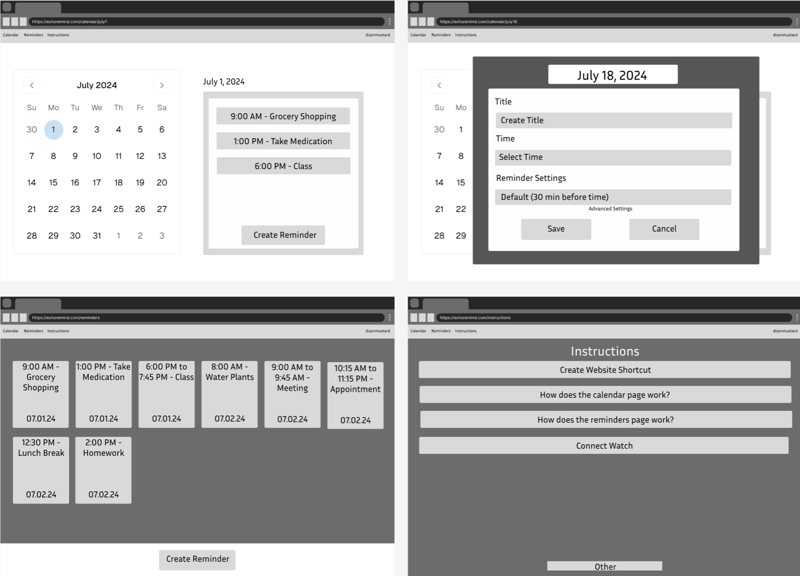Figure 1

For our initial design, we have monotone colors to depict the basic setup of the website. Some of the aspects of the initial design include:

* A Calendar page: Using a calendar component the user can view the current day and select a specific day in the month to view the reminders for the day or go forwards and backwards between the months and then select a day. On this page the user can create a new reminder or edit existing reminders for the day that are listed on the right hand side.
* A Reminders page: There is a listing of every reminder the user has beginning with the first of the current month. On this page the user can create a new reminder or edit existing reminders.
* An Instructions page: There is a listing of possible instructions the user may need to properly set up their website and devices or answering common questions the user may have about the website itself. Once the user selects an instruction they wish to view, the user will be redirected to a different page that lists the steps for the specific instruction.

The client has difficulty using technology so the simple design was created in the hopes that the client can easily navigate the website when the need arises for them.

| Pros | * Simple design for users * Self explanatory buttons and easily identifiable pages * Ability to create new reminders or edit existing reminders |
| --- | --- |
| Cons | * Dull color, may have difficulty distinguishing between background and modal * User must click many buttons |

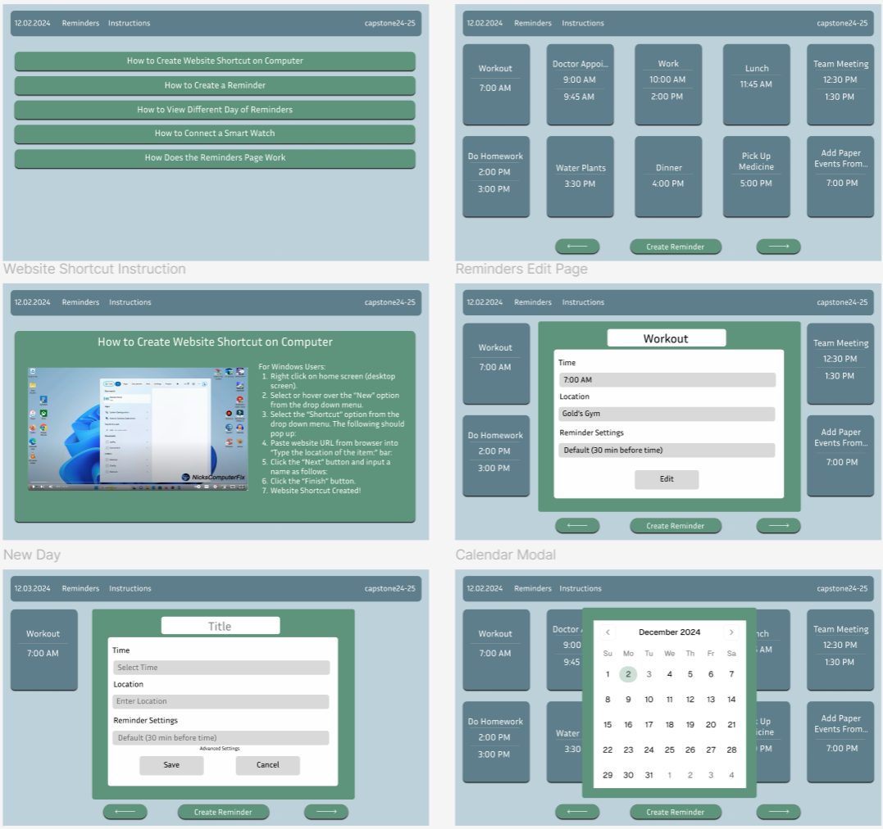

Figure 2

The second full design created takes into consideration the clients feedback where the initial design was still too complicated, the words were too small for the user to read, and that they would prefer the colors blue and green for the design. Changes to the design:

* No Calendar page: Calendar page was changed to a modal so that the user isn’t burdened with two pages that list reminders
* Reminders page: this page now consists of only the reminders for the selected day so as not to overload the user with information, this page is the one that has the function to move forward or backward a day
* Instructions page: now the instructions with steps will include a video that goes along with the steps so that the user can watch the video instead if they have difficulties with reading comprehension
* Adding reminders: reminders can now only be added on the reminders page so that the design is simplified further for the user

With the added changes, the user interface is more simplified and easier to use than before and color has been added to ensure that our client can be more enticed to the website.

| Pros | * easier to navigate * colors added to the clients taste |
| --- | --- |
| Cons | * added modals may be complicated to the user |

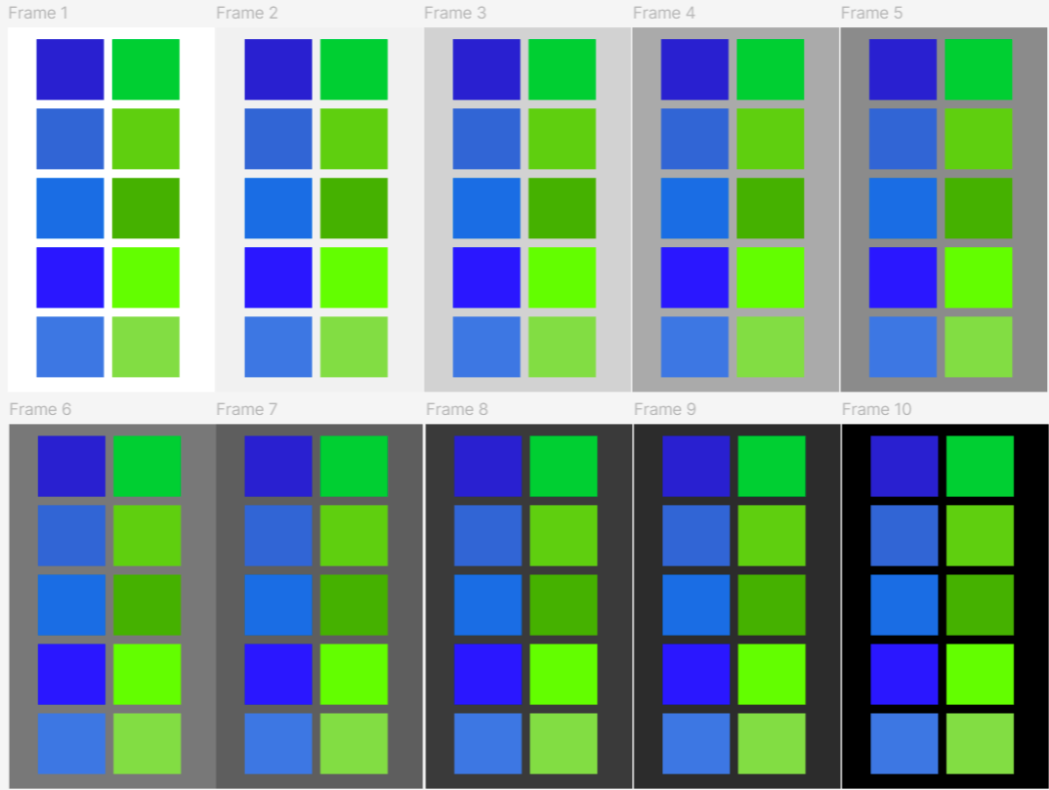

Figure 3

The design of the overall website wasn’t changed from the second design option, however, the client was hoping that the colors would be different shades to demonstrate their favorite colors properly. To ensure that the coloring was to the clients requirements, we gave the client the above design so that they could choose from the 5 green and blue color combinations to ensure it aligned with the vision they had for the colors. Along with the main color options are possible background colors they could choose from to go along with their selection.

The client selected the 4th blue and green color combination with either the white or black background color.

### Section E. Concept Evaluation and Selection

To ensure that the final design meets the client’s needs effectively while adhering to the established objectives and constraints, we conducted a structured evaluation of the design concepts presented in Section D. Using a **Decision Matrix**, we evaluated the three design concepts based on key selection criteria, including simplicity, usability, cost, reliability, and accessibility. Feedback from the client and sponsor was incorporated to refine the evaluation process.

#### E.1 Selection Criteria and Weighting Factors

We defined the following selection criteria for evaluating the design concepts:

1. **Simplicity** (Weight: 0.3): The design must be easy to navigate for users who are not technologically inclined.
2. **Usability** (Weight: 0.25): The interface should allow the user to manage reminders effectively without frustration.
3. **Accessibility** (Weight: 0.2): The application should be compatible with assistive technologies and various devices.
4. **Cost Efficiency** (Weight: 0.15): The design should remain within the project’s allocated budget of $1,000.
5. **Reliability** (Weight: 0.1): The design must ensure robust functionality without frequent bugs or interruptions.

#### E.2 Evaluation Metrics

Each criterion was scored on a scale of 1 to 10:

* 10: Fully meets the criterion.
* 1: Does not meet the criterion.

**Table 1. Example of a Decision Matrix.**

| | **Design Concept** | | --- | | | **Simplicity (0.3)** | | --- | | | **Usability (0.25)** | | --- | | | **Accessibility (0.2)** | | --- | | **Cost Efficiency (0.15)** | **Reliability (0.1)** | **Total Score** |
| --- | --- | --- | --- | --- | --- | --- | --- | --- | --- | --- |
| **Initial Design (Fig. 1)** | **6** | **6** | **7** | **9** | **8** | **7.05** |
| **Refined Design (Fig. 2)** | **8** | **9** | **9** | **8** | **8** | **8.4** |
| **Color-Enhanced Design (Fig. 3)** | **9** | **9** | **9** | **7** | **8** | **8.5** |

***Note:*** Weights can be assigned to each criterion if desired.

#### E.4 Selected Design and Rationale

The **Color-Enhanced Design (Figure 3)** achieved the highest total score, emphasizing its ability to meet the client’s needs while maintaining a balance between simplicity, usability, and accessibility. This design incorporates the client’s feedback on color preferences and layout simplicity, ensuring higher user satisfaction. While it scored slightly lower on cost efficiency due to potential design refinements, the benefits of improved client usability outweigh the minor increase in costs.

#### E.5 Client Feedback and Finalization

During bi-weekly meetings with the client, we presented the results of our evaluation and received confirmation that the Color-Enhanced Design aligns with their expectations. Their satisfaction with the selected colors and the simplified layout affirmed our choice. Moving forward, this design will serve as the foundation for development, with iterative refinements based on ongoing client feedback.

### Section F. Design Methodology

This section provides a detailed explanation of the methods that will be used to help evaluate, improve, and evolve the design through the iterative engineering design process. Verification ensures that the design meets all specifications, while validation confirms that the design functions as intended such to meet the client’s needs.

#### F.1 Experimental Methods

Our back-end will be testing with prototype html for the front-end web pages to verify that API requests and database functionality is working properly. We will be checking to make sure we have all the necessary functions that the front-end needs.

Our front-end will be working with our client to ensure the layout is how she would like it. With each iteration, we will meet to discuss the changes and her feedback.

We will be testing Alexa and the Firebase Cloud messaging once we receive the devices that we are ordering. We will test all functionality before presenting to our client for her personal testing. We will be using the application ourselves once we come to a finalized version and observe any changes or additions that will need to be made.

#### F.2 Architecture/High-level Design

Our application framework, pictured in Section G figure 1, was developed over a two-week sprint to refine its design and functionality. This iterative process ensured a robust and user-friendly system that meets the needs of our users.

The application allows users to interact with reminders across all devices, whether they are displayed visually or read aloud. While the computer and phone provide full access to the application and its features via our website, the phone and smartwatch offer additional convenience by enabling users to create reminders through Alexa.

To power our back-end architecture, we are leveraging Supabase, where our PostgreSQL databaseis hosted. This database securely stores key information such as events, reminders, and user details. For more details on our database schema, see Section G figure 2. Additionally, we are integrating APIs to retrieve data from users’ Google or Outlook calendars. Having calendar synchronization means our application can display all events in a unified view, regardless of their origin. This process works bidirectionally—events created in our application are automatically updated to the user’s chosen calendar, ensuring a seamless experience.

For Alexa-enabled functionality, we have developed a custom Alexa Skill using the Alexa Skills Kit. Communication between Alexa and our server is managed through Amazon Web Service Lambda, enabling users to create events and reminders via voice commands. Furthermore, we use Firebase Cloud Messaging to handle the delivery of reminders to all user devices, ensuring notifications are timely and reliable.

#### F.3 Validation Procedure

Since our team is collaborating with a specific client for this project, we have established bi-weekly meetings to review our designs at every stage. In early December, we met to finalize the UI design, focusing on key elements such as color scheme, font size, and layout for the application. These details were agreed upon, allowing us to move forward with the coding process during the winter break.

At the beginning of the spring semester, we plan to present a functional version of the live website, enabling our client to test its usability by navigating through the pages and layouts. During this time, we will also clarify the implementation details for features such as Alexa integration, notifications, and text-to-speech, which we plan to work on during the break.

Following this initial testing phase, we will enter another round of development to incorporate the desired features. Our goal is to deliver a final prototype by late March, allowing the client to fully experience the application's capabilities, including the reminders, Alexa integration, and overall usability. We anticipate meeting in person to guide the client through connecting her phone and watch to the application. During this session, we will take detailed notes on her feedback. If an in-person meeting isn’t possible, we will provide comprehensive instructions and discuss her feedback during our next meeting.

### Section G. Results and Design Details

Figure 1.

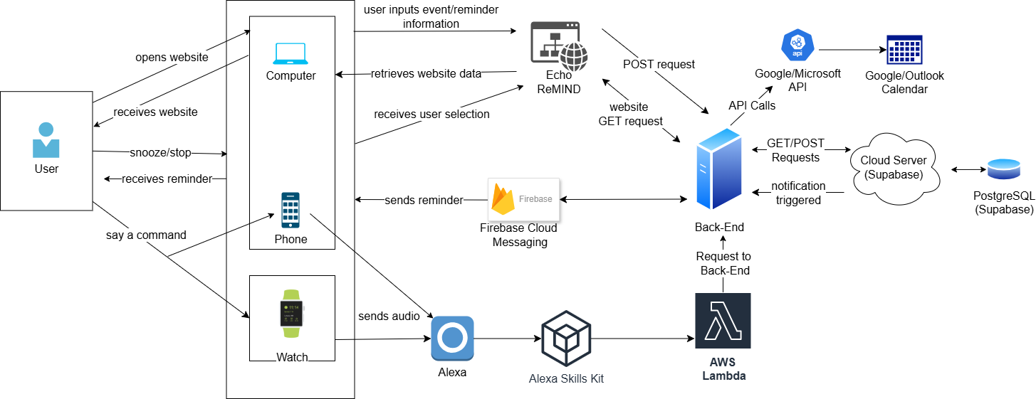

Figure 2.

.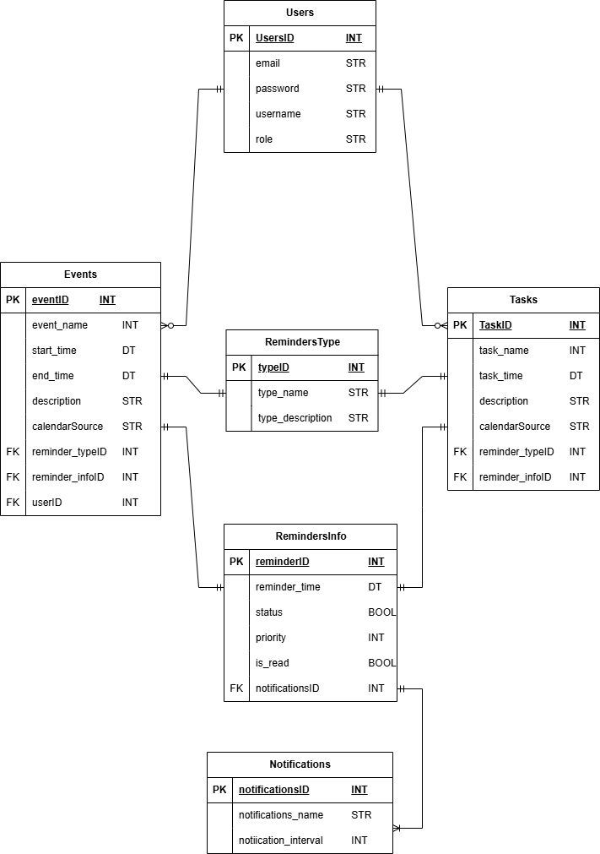

#### Supporting Figures

* **Figure 1**: Data flow diagram highlighting the interaction between user devices, the server, and APIs.
* **Figure 2**: Database schema illustrating table relationships for events, users, and notifications.

#### G.1 Modeling Results (example subsection)

* **Data Flow Diagrams**: Figure 1 illustrates the data flow between client devices, the backend server, and integrated APIs.
* **Database Structure**: The PostgreSQL database design (shown in Figure 2) optimizes data storage for events, reminders, and user details, ensuring secure and efficient access.

#### G.2 Prototyping and Testing Results (example subsection)

* **Visual Interface**: Initial wireframes evolved into a functional UI designed for simplicity. Client feedback led to refinements and emphasized usability.

#### G.3. Final Design Details/Specifications: The final design addresses the problem statement effectively by empowering users with PTSD and TBI through accessible technology. Key features include:

* **Cross-Platform Access**: Compatibility across phones, smartwatches, and Alexa-enabled devices.
* **Customizable Reminders**: Users can adjust notification intervals and priorities to suit their needs.
* **Scalable Architecture**: Built using Supabase for reliable backend support and Firebase for notification delivery.

### Section H. Societal Impacts of Design

#### H.1 Public Health, Safety, and Welfare

Our design prioritizes user safety and well-being through the following features:

* **Data Security:** Safeguarding sensitive information, reducing the risk of breaches that could harm users.
* **Accessible Interface:** Simplified navigation reduces user frustration and cognitive load, especially for individuals with PTSD and TBI.
* **Reliable Notifications:** The text-to-speech reminders provide timely support for daily tasks, improving time management and reducing anxiety.

By addressing these elements, the design enhances public health by empowering users to live independently, with improved mental well-being and reduced caregiver reliance.

#### H.2 Societal Impacts

The application fosters user independence, enabling individuals to manage their schedules without constant external support.

* **Reduced Caregiver Dependence**: This empowers users, improving self-esteem and quality of life.
* **Increased Awareness**: By highlighting the needs of individuals with PTSD and TBI, the project promotes inclusivity in technology design.

#### H.3 Environmental Impacts

The project minimizes environmental impact by leveraging existing devices:

* **Resource Efficiency**: Instead of requiring new hardware, the design integrates with devices users already own, reducing e-waste.
* **Cloud-Based Infrastructure**: Efficient use of cloud services reduces the energy consumption associated with physical servers.

#### H.4 Global Impacts

The application’s adaptability ensures its relevance across cultural and linguistic boundaries:

* **Language Localization**: The text-to-speech and interface components can be tailored to various languages, making it suitable for global use.
* **Addressing Universal Needs**: PTSD and TBI are global challenges, and this application can serve as a tool for support worldwide.

### Section I. Cost Analysis

As of the end of the fall semester, we have not officially made any purchases. The current plan is to begin our purchases over the break, or at the start of the spring semester. As of right now, our purchases will include the following:

| Item | Description | Cost | Vendor | Date Received |
| --- | --- | --- | --- | --- |
| Fitbit Versa 4 | Watch provided by us to allow the notifications to reach the user directly | Estimated at $199.95 | N/A | N/A |
| Bluetooth Earpiece | Earpiece to enhance the text-to-speech capability | Estimated range at $50 - $100 | N/A | N/A |
| Supabase Account | Platform to host our back-end servers | Free | Supabase | 11/25/24 |
| Google Workspace | A subscription to allow us to use Google Calendar API? | N/A | Google | N/A |
| Microsoft | A subscription to allow us to use Microsoft Graph API? | N/A | Microsoft | N/A |

### Section J. Conclusions and Recommendations

At the start, our team consulted our client about what drove them to request the project. They found that they would accidentally double book themselves for the same time slots due to having multiple calendars. To help with the double booking, our design pulls data from their existing calendars and places them as reminders in our website so that the client has one place that stores all their events.

Specifically for the design, the client mentioned that they were not technologically savvy and were hoping that our design would be much simpler than other versions that they are currently using. In order to create a simpler design, we initially created what we believed was a simpler design (see Section D, Figure 1) than what already existed and tailors to their hopes to have their reminders in one place as well as the ability to push any reminders they created on our website to their other existing calendars so that every calendar application they use has all the information needed. The initial design encompasses a simple user interface that only asks for the necessary information needed to create reminders and would be self explanatory in terms of how to operate the interface.

Once the initial design was presented to the client, we had to change our design to the second design created (see Section D, Figure 2). The client expressed that our initial design was not as simple as we had initially thought and wanted the design to be simpler. In order to achieve this, our second design only displays the most basic information on the reminders in a grid formation that allows the client to view only a day's worth of reminders at a time. The ability to create reminders in multiple places was removed so that the client only has one place to navigate to when creating reminders. The instructions page was updated to incorporate a video so that the client would be able to see the step-by-step instructions occurring so that there would be less confusion on what the steps meant.

Once presented with the second design, the client approved of the design, but was hoping for the colors to be different as the color combination was not what they were hoping it would be. To ensure that every aspect of the design was to the clients satisfaction, we then provided them with color combination options (see Section D, Figure 3) so that they may select what works best for them.

### Appendix 1: Project Timeline

We created this timeline to create our schedule for the Fall 2024 semester. We included a Team Check-in over break to evaluate where we are and create the timeline for the Spring 2025 semester. We divided the back-end and front-end between pairs in the group to effectively work on parts in parallel.

November is dedicated to beginning the base code, finalizing the UI design, and completing the necessary documentation. December will be dedicated to continuing the code for back-end and front-end, as well as beginning to work on the specific features that our application offers. These include Alexa, Firebase Cloud Messaging, Text-to-Speech, and any additional research needed.

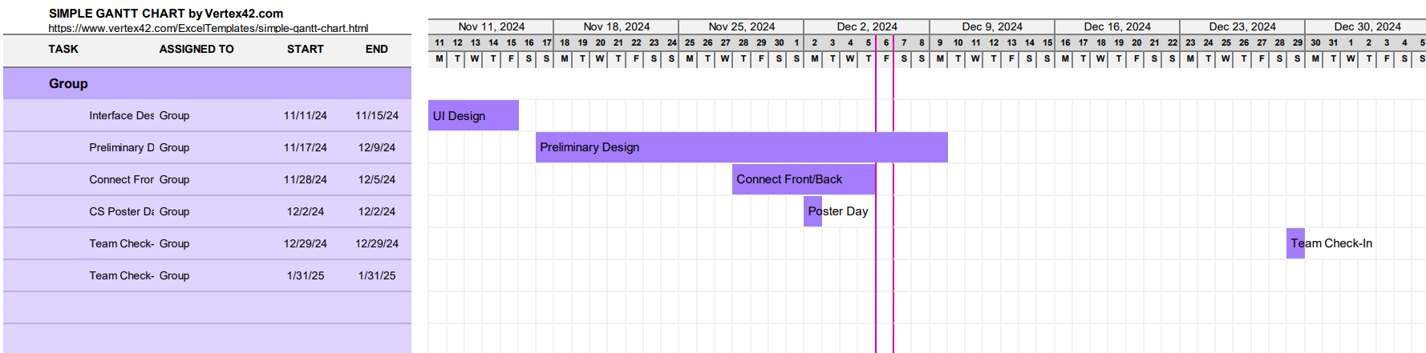

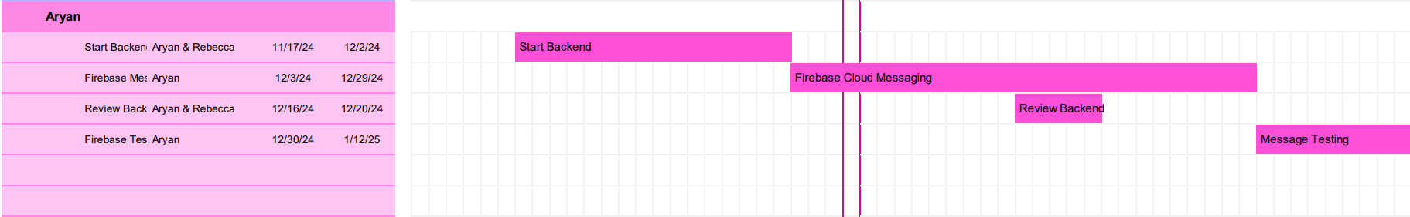

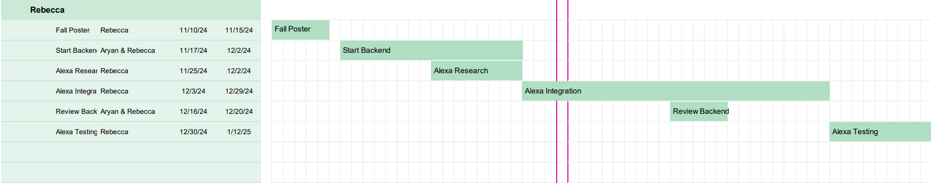

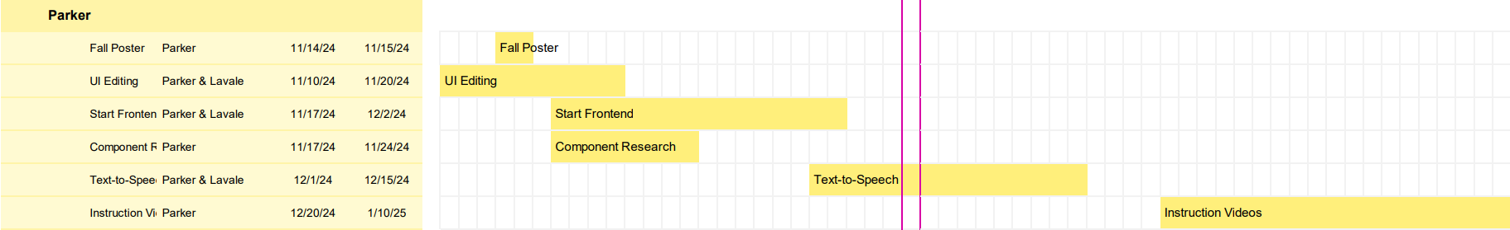

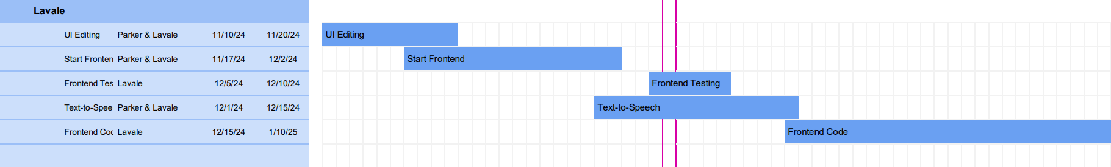

### Appendix 2: Team Contract (i.e. Team Organization)

Below is our Team Contract that we created at the beginning of the Fall 2024 Semester. It includes individual roles and responsibilities, group expectations, and the planned time commitments.

Step 1: Get to Know One Another. Gather Basic Information.

**Task:** This initial time together is important to form a strong team dynamic and get to know each other more as people outside of class time. Consider ways to develop positive working relationships with others, while remaining open and personal. Learn each other’s strengths and discuss good/bad team experiences. This is also a good opportunity to start to better understand each other’s communication and working styles.

| ***Team Member Name*** | ***Strengths each member bring to the group*** | ***Other Info*** | ***Contact Info*** |
| --- | --- | --- | --- |
| Rebecca Browder | Organization, Communication, and Open-mindedness | I enjoy creative projects and activities. | browderrj@vcu.edu |
| Aryan  Garg | Communication,  Dedication, and  Flexibility | I enjoy being a part of a team and meeting new people. | garga8@vcu.edu |
| Lavale Butterfield | Communication, time-management, and problem solving | I enjoy making projects and being a part of a team. | butterfieldl@vcu.edu |
| Parker Dizon | Adaptability,  Positive, and  Determination | I enjoy meeting new people and learning new information to create new projects. | dizonpr@vcu.edu |

| ***Other Stakeholders*** | ***Notes*** | ***Contact Info*** |
| --- | --- | --- |
| Tamer Nadeem | Technical Advisor. | tnadeem@vcu.edu |
| Kristie Yelinek, | Project Sponsor, Facilitator between client | kristie.yelinek@qlplus.org |

Step 2: Team Culture. Clarify the Group’s Purpose and Culture Goals.

**Task:** Discuss how each team member wants to be treated to encourage them to make valuable contributions to the group and how each team member would like to feel recognized for their efforts. Discuss how the team will foster an environment where each team member feels they are accountable for their actions and the way they contribute to the project. These are your Culture Goals (left column). How do the students demonstrate these culture goals? These are your Actions (middle column). Finally, how do students deviate from the team’s culture goals? What are ways that other team members can notice when that culture goal is no longer being honored in team dynamics? These are your Warning Signs (right column).

**Resources:** More information and an example Team Culture can be found in the Biodesign Student Guide “Intentional Teamwork” page ([webpage](https://biodesignguide.stanford.edu/toolkit/intentional-teamwork/) | [PDF](https://biodesignguide.stanford.edu/wp-content/uploads/2022/07/Intentional-Teamwork-v2.pdf))

| ***Culture Goals*** | ***Actions*** | ***Warning Signs*** |
| --- | --- | --- |
| Being on time | * Meeting times are added to group Calendar * Reminder message sent day of meetings | * Student is late consistently - Student is issued a warning. * Student misses meetings without explanations - Issue is brought up with the professor. |
| Work split-up evenly | * Ensure that nobody does too much work * Keep in contact with team members to make sure everyone is able to complete their work | * A student works a lot longer than other people in the group * A student takes a lot less time to complete their task than others |
| Contribute strengths and learn from other team members. | * Continuously learn from team members by asking questions. | * Not communicating effectively * Not putting in effort |

Step 3: Time Commitments, Meeting Structure, and Communication

**Task:** Discuss the anticipated time commitments for the group project. Consider the following questions (don’t answer these questions in the box below):

* What are reasonable time commitments for everyone to invest in this project?
* What other activities and commitments do group members have in their lives?
* How will we communicate with each other?
* When will we meet as a team? Where will we meet? How Often?
* Who will run the meetings? Will there be an assigned team leader or scribe? Does that position rotate or will same person take on that role for the duration of the project?

**Required:** How often you will meet with your faculty advisor advisor, where you will meet, and how the meetings will be conducted. Who arranges these meetings?

See examples below.

| ***Meeting Participants*** | ***Frequency***  ***Dates and Times / Locations*** | ***Meeting Goals***  ***Responsible Party*** |
| --- | --- | --- |
| Students Only | As Needed, On Discord Voice Channel | Update group on day-to-day challenges and accomplishments  (Parker will record the information that we go over to keep faculty advisor updated in meetings) |
| Students Only | Every Thursday after 2:30PM in the Cabell Library | Actively work on project  (Parker will record necessary information for future meetings and keeping the faculty advisor up to date) |
| Students + Faculty advisor | Thursdays 12:00PM-12:30PM either on Zoom or in-person in ERB 2330 | Update faculty advisor and get answers to our questions  (Parker will take down meeting notes) |
| Project Sponsor/Client | Bi-weekly on Zoom  Time: 12:00PM - 12:30PM | Update project sponsor, make sure we are on the right track, and ask questions about what the client would want  (Parker will take down meeting notes) |

Step 4: Determine Individual Roles and Responsibilities

**Task:** As part of the Capstone Team experience, each member will take on a leadership role, ***in addition to*** contributing to the overall weekly action items for the project. Some common leadership roles for Capstone projects are listed below. Other roles may be assigned with approval of your faculty advisor as deemed fit for the project. For the entirety of the project, you should communicate progress to your advisor specifically with regard to your role.

* **Before meeting with your team**, take some time to ask yourself: what is my “natural” role in this group (strengths)? How can I use this experience to help me grow and develop more?
* **As a group,** discuss the various tasks needed for the project and role preferences. Then assign roles in the table on the next page. Try to create a team dynamic that is fair and equitable, while promoting the strengths of each member.

**Communication Leaders**

**Suggested:** Assign a team member to be the primary contact for the client/sponsor. This person will schedule meetings, send updates, and ensure deliverables are met.

**Suggested:** Assign a team member to be the primary contact for faculty advisor. This person will schedule meetings, send updates, and ensure deliverables are met.

**Common Leadership Roles for Capstone**

1. **Project Manager:** Manages all tasks; develops overall schedule for project; writes agendas and runs meetings; reviews and monitors individual action items; creates an environment where team members are respected, take risks and feel safe expressing their ideas.

**Required:** On Edusourced, under the Team tab, make sure that this student is assigned the Project Manager role. This is required so that Capstone program staff can easily identify a single contact person, especially for items like Purchasing and Receiving project supplies.

1. **Logistics Manager:** coordinates all internal and external interactions; lead in establishing contact within and outside of organization, following up on communication of commitments, obtaining information for the team; documents meeting minutes; manages facility and resource usage.
2. **Financial Manager:** researches/benchmarks technical purchases and acquisitions; conducts pricing analysis and budget justifications on proposed purchases; carries out team purchase requests; monitors team budget.
3. **Systems Engineer:** analyzes Client initial design specification and leads establishment of product specifications; monitors, coordinates and manages integration of sub-systems in the prototype; develops and recommends system architecture and manages product interfaces.
4. **Test Engineer:** oversees experimental design, test plan, procedures and data analysis; acquires data acquisition equipment and any necessary software; establishes test protocols and schedules; oversees statistical analysis of results; leads presentation of experimental finding and resulting recommendations.
5. **Manufacturing Engineer:** coordinates all fabrication required to meet final prototype requirements; oversees that all engineering drawings meet the requirements of machine shop or vendor; reviews designs to ensure design for manufacturing; determines realistic timing for fabrication and quality; develops schedule for all manufacturing.

| ***Team Member*** | ***Role(s)*** | ***Responsibilities*** |
| --- | --- | --- |
| Rebecca Browder | Logistics Manager/System Engineer | * Organize meetings, obtaining information for the team, establishing contact with outside organizations * Analyzes Client design specifications, recommends system architecture and manages product interfaces |
| Parker Dizon | Recorder/Financial Manager/Test Engineer | * Keep a record of meeting notes, what was accomplished, who’s doing what * Research what purchases/subscriptions we may need to complete the project * Tests for errors or bugs and ensure that the product is functioning how it should after lead tester |
| Lavale Butterfield | Lead Test engineer/ Project Manager | * Test for bugs and make sure the product is functioning correctly. * Make sure deadlines are met. |
| Aryan Garg | Project Manager/  System Engineer | * Write a schedule for the team * Oversee team * Make specifications for designs |

# 

Step 5: Agree to the above team contract

*Team Member: Aryan Garg Signature: Aryan Garg*

*Team Member: Lavale Butterfield Signature: Lavale Butterfield*

*Team Member: Parker Dizon Signature: Parker Dizon*

*Team Member: Rebecca Browder Signature: Rebecca Browder*

### 

### 

### 

### 

### References

[1] Teach Engineering. *Engineering Design Process.* TeachEngineering.org. Retrieved September 2, 2024. https://www.teachengineering.org/populartopics/designprocess

[2] Veterans Affairs. (2018, September 13). *Va.gov: Veterans Affairs.* How Common is PTSD in Adults? Retrieved September 28, 2024. https://www.ptsd.va.gov/understand/common/common_adults.asp

[3] Veterans Affairs. (2018, November 29). *Va.gov: Veterans Affairs*. TBI Symptoms, Effects, & Veteran Support. Retrieved September 28, 2024. https://www.mentalhealth.va.gov/tbi/index.asp

[4] Kuhn, E. (2019, August 1). *PTSD Coach App*. Office of Research & Development. Retrieved September 29, 2024. https://www.mentalhealth.va.gov/tbi/index.asp